In this document i will display to you the functionality of this website I made step by step.

This is the navigation bar and slider part when user open the website, the default navigation is transparent as it can looks more impressive and modern, the slider will automatically change by default time, user can also manually change the image if they want.

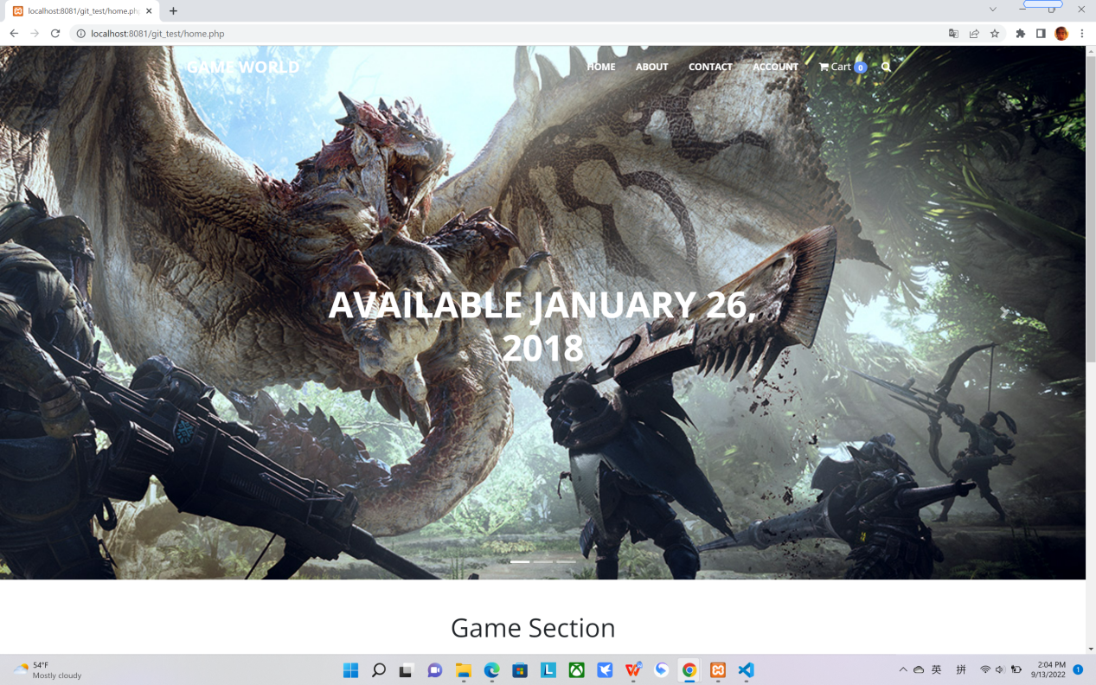

When user scroll down the navigation bar it will change its background color and fonts color to allow user can clearly see each section in the navigation bar without influenced by slider image

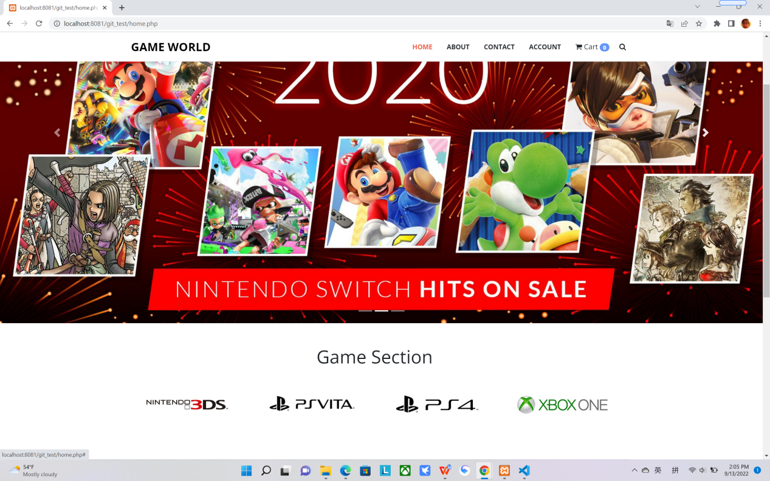

There are 4 section to lead user to select their desire platform, (demo only so i didn’t actually create these 4 pages),then below are popular and coming soon section to display most popular games.

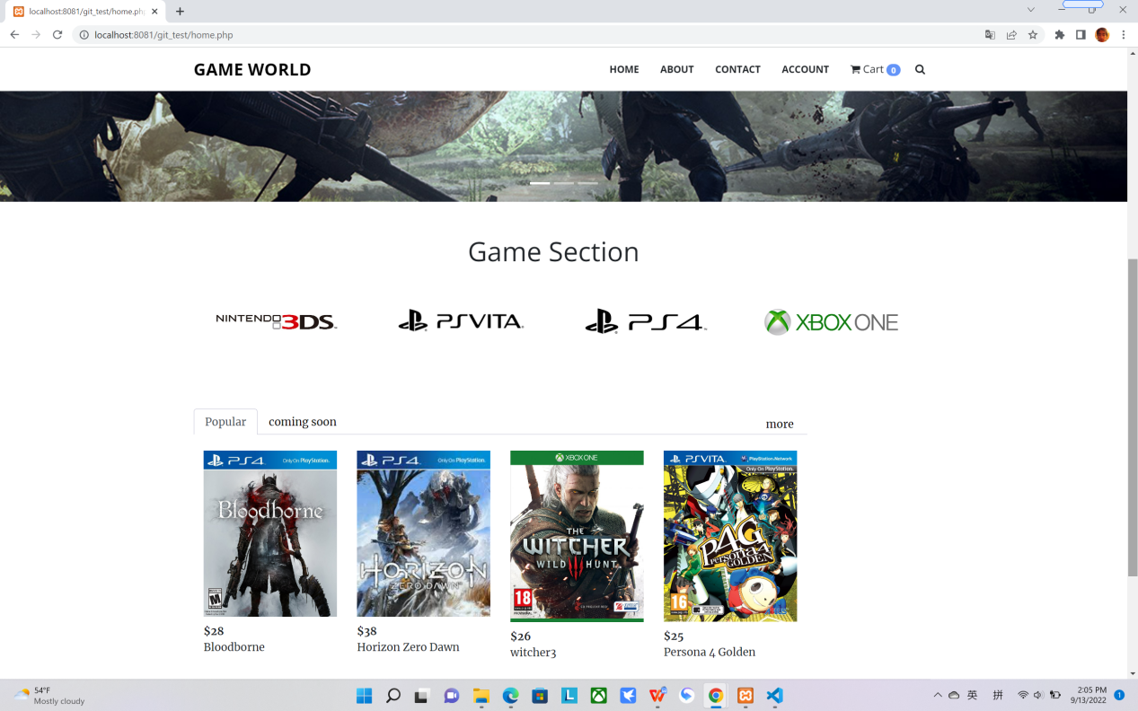

If you click the product from popular/coming soon it will head to the display page to show all the info from this product.

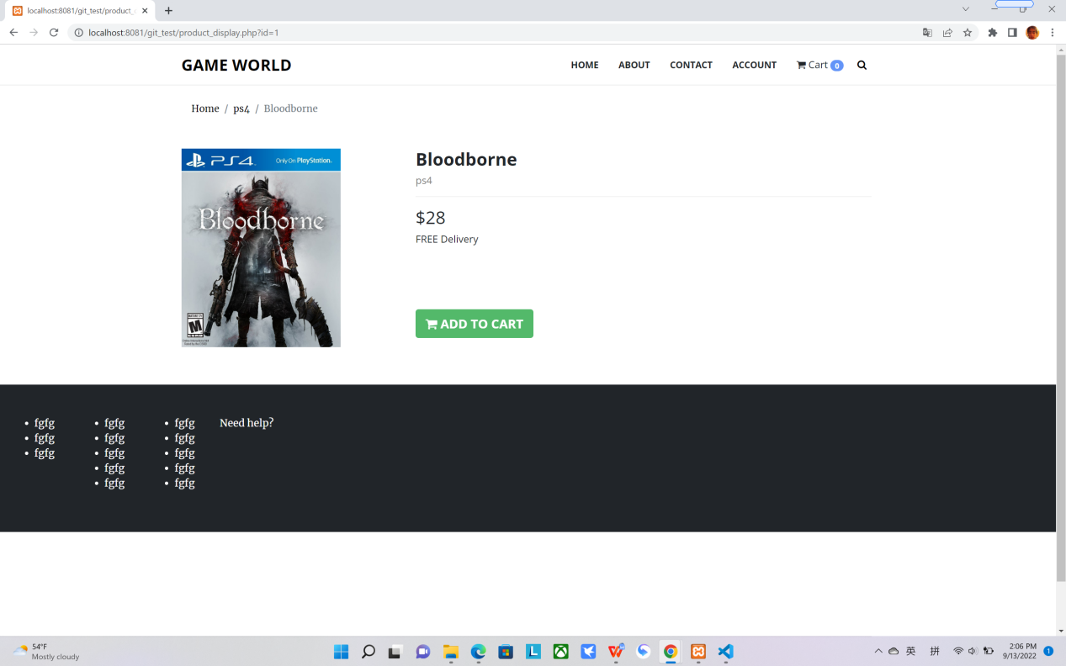

If you press ‘add to the cart’ button it will head to the cart page,shows all the info related to this product 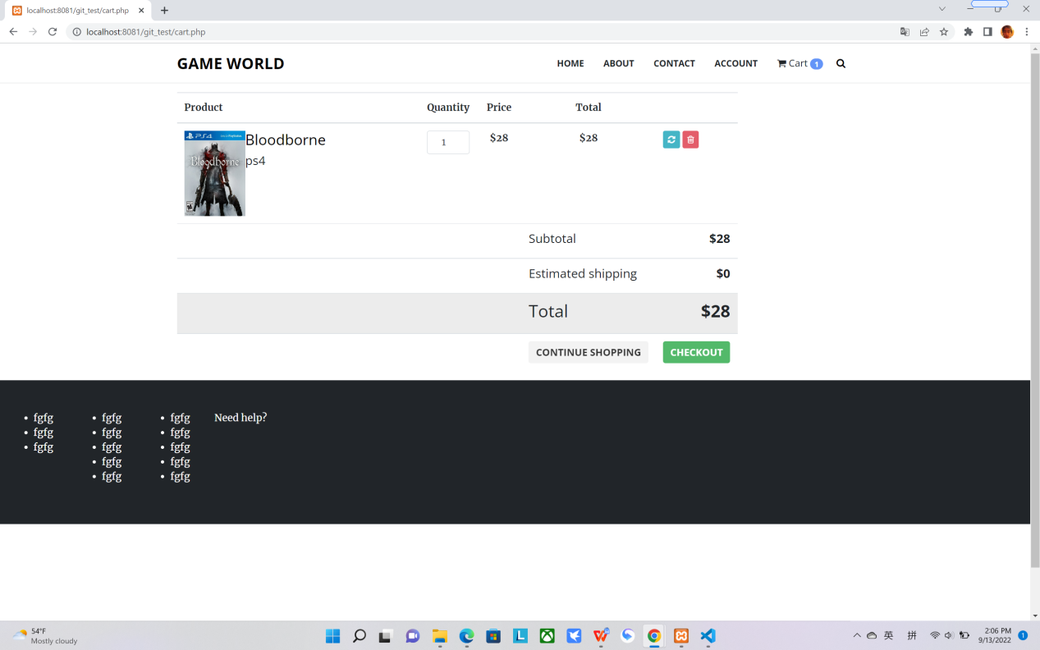

If you change to the quantity it will automatically change the price and total price as well

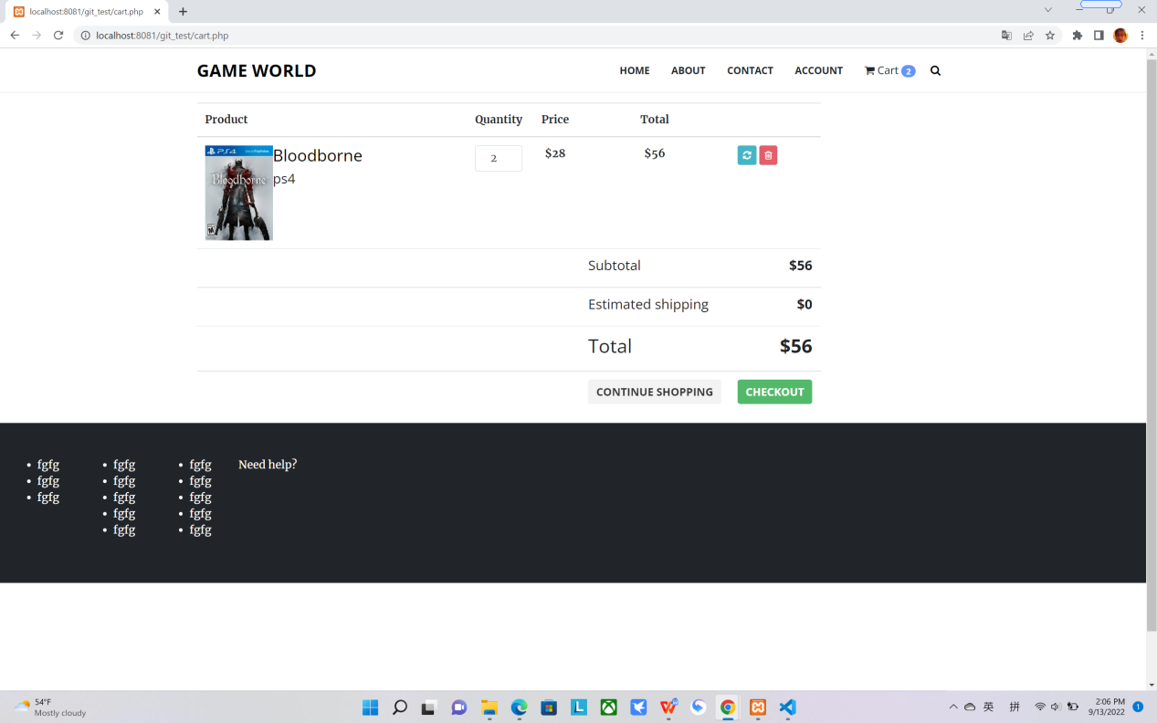

If you remove all the product it will tell you the cart is empty

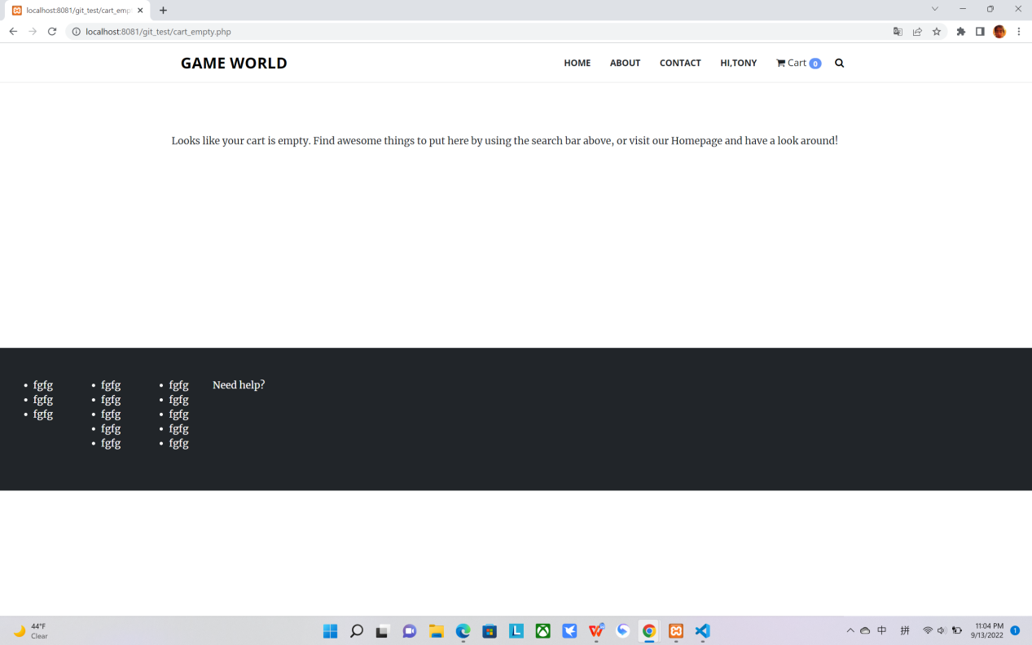

If you add another product it will change the total price as well

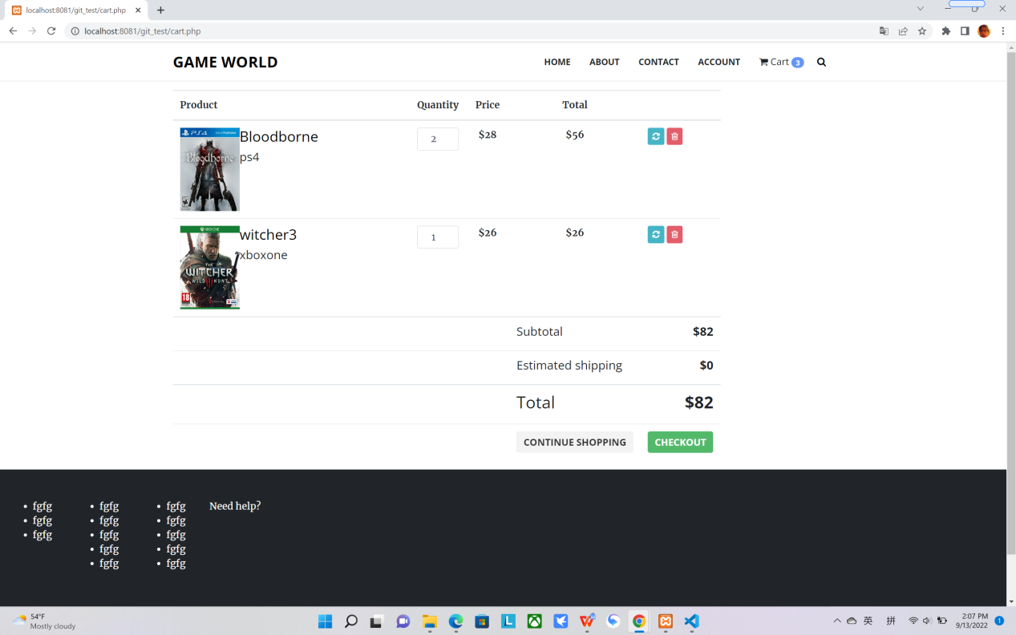

If you are guest and press checkout the website will head you to the login page.

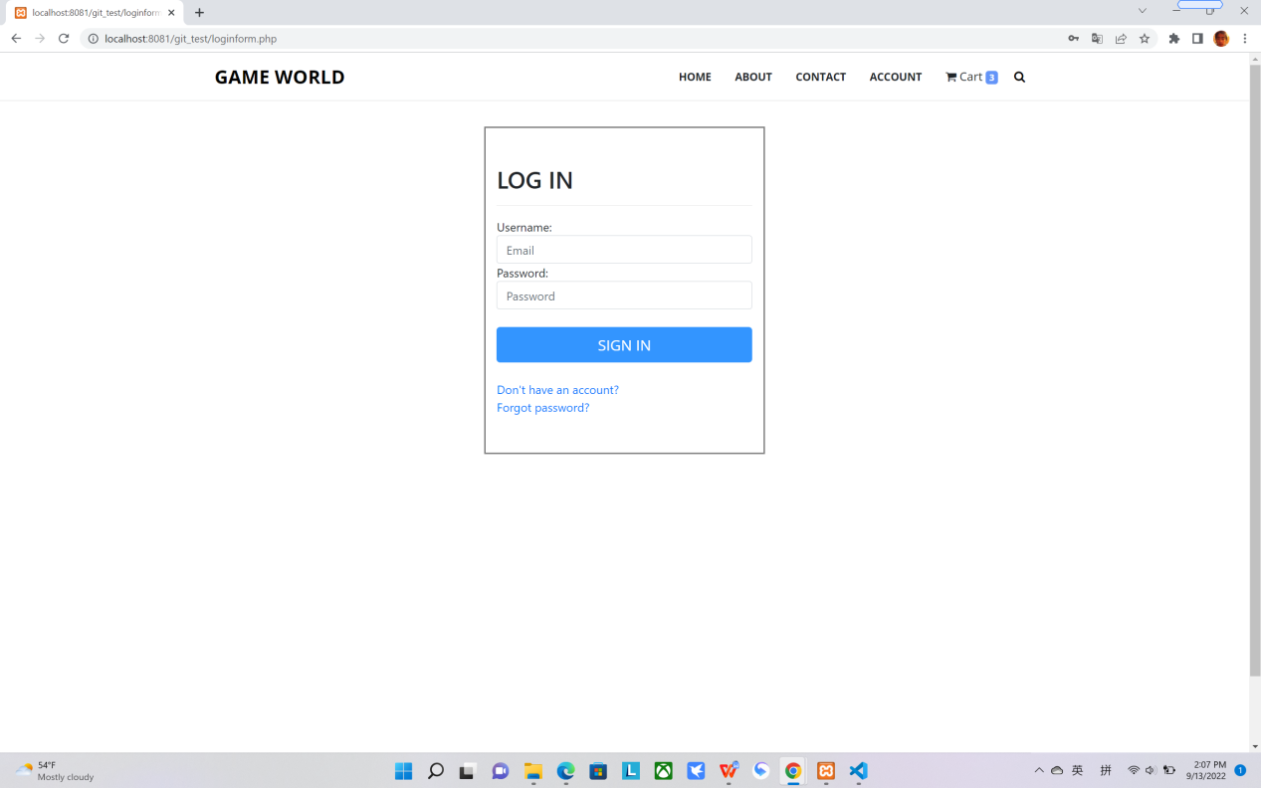

If you don’t have account before it will give you an error to let you know you need to sign in first

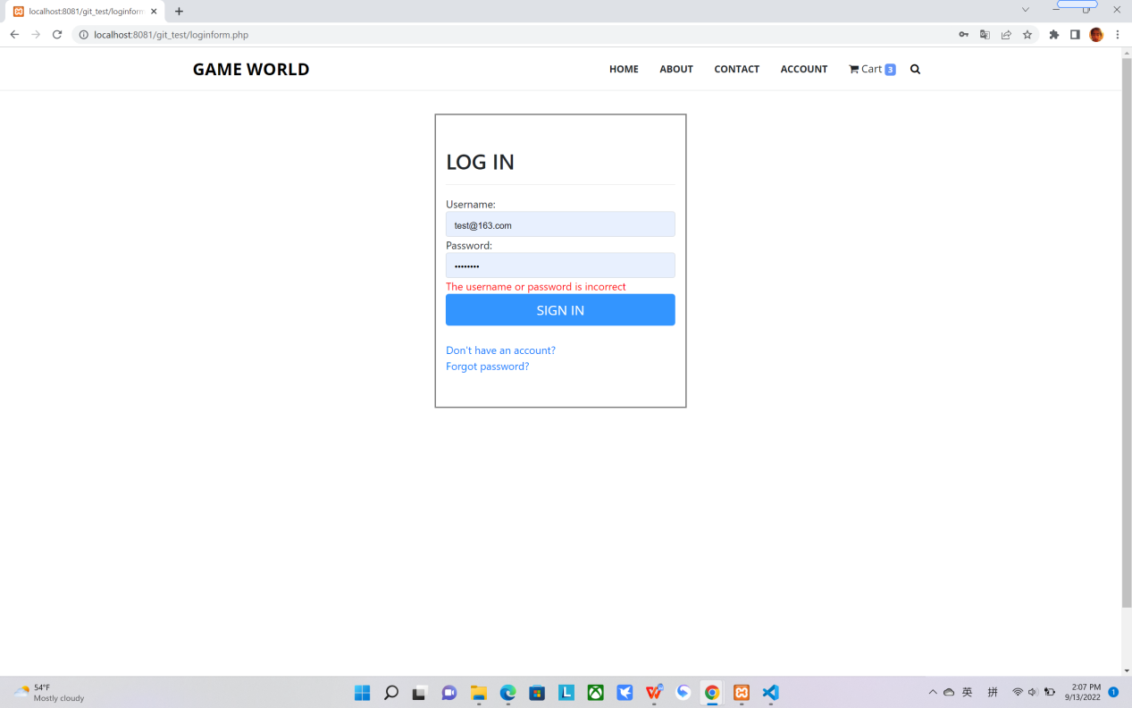

Same as forgot password if you don’t have account it will warning you need to register first

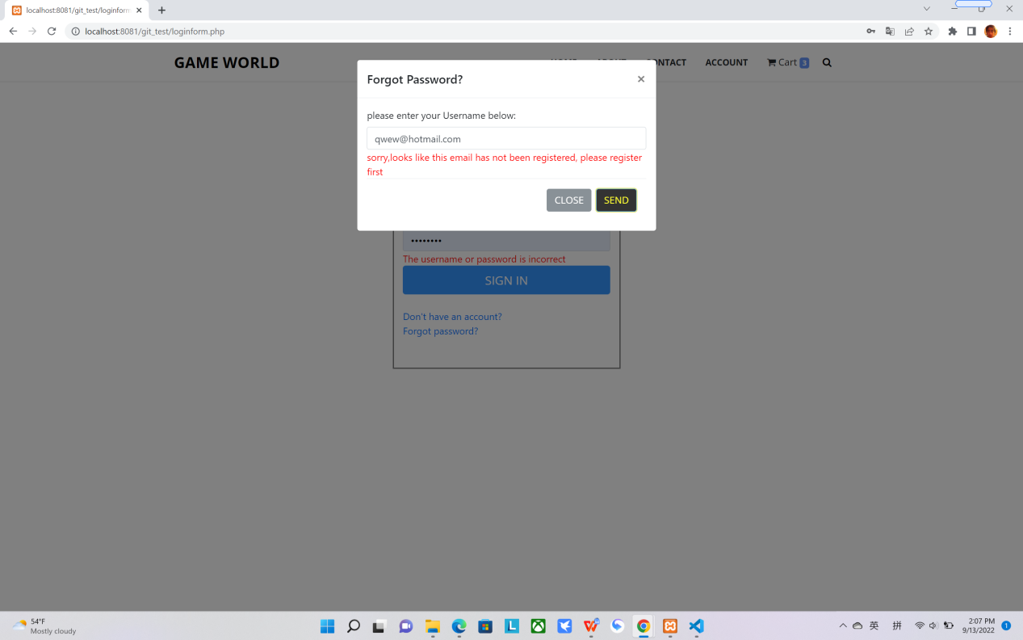

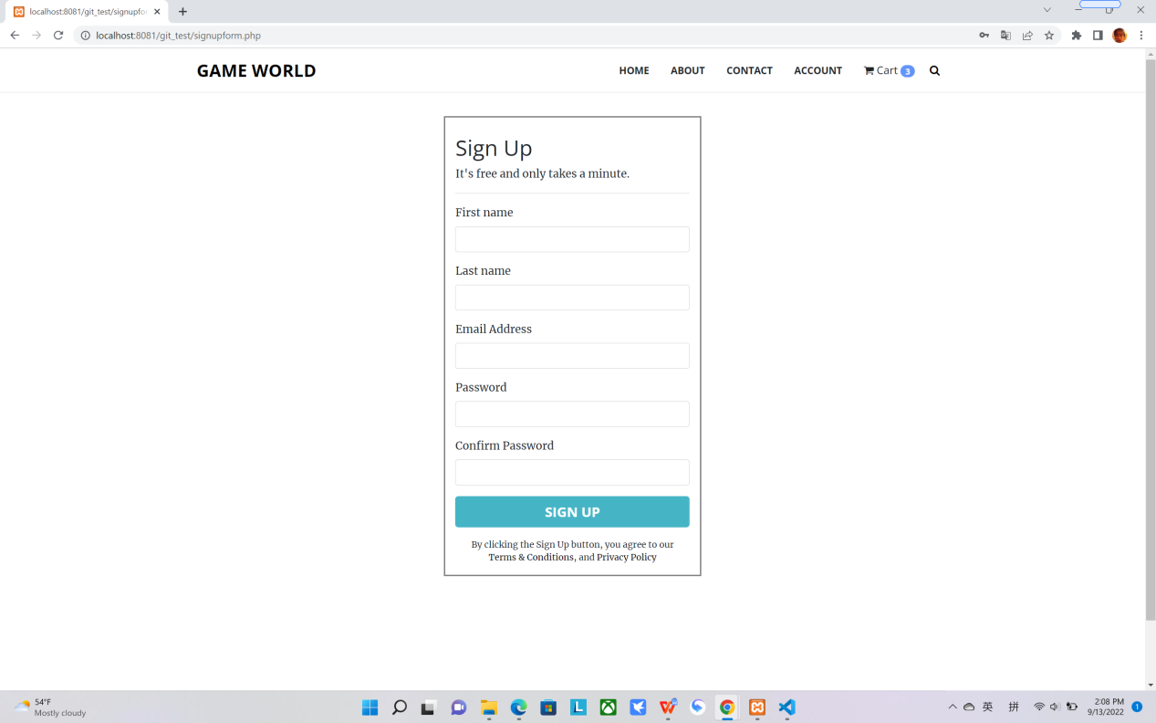

Once you complete the signup, the ‘account’ in the navigation bar will change to Hi,{your name}

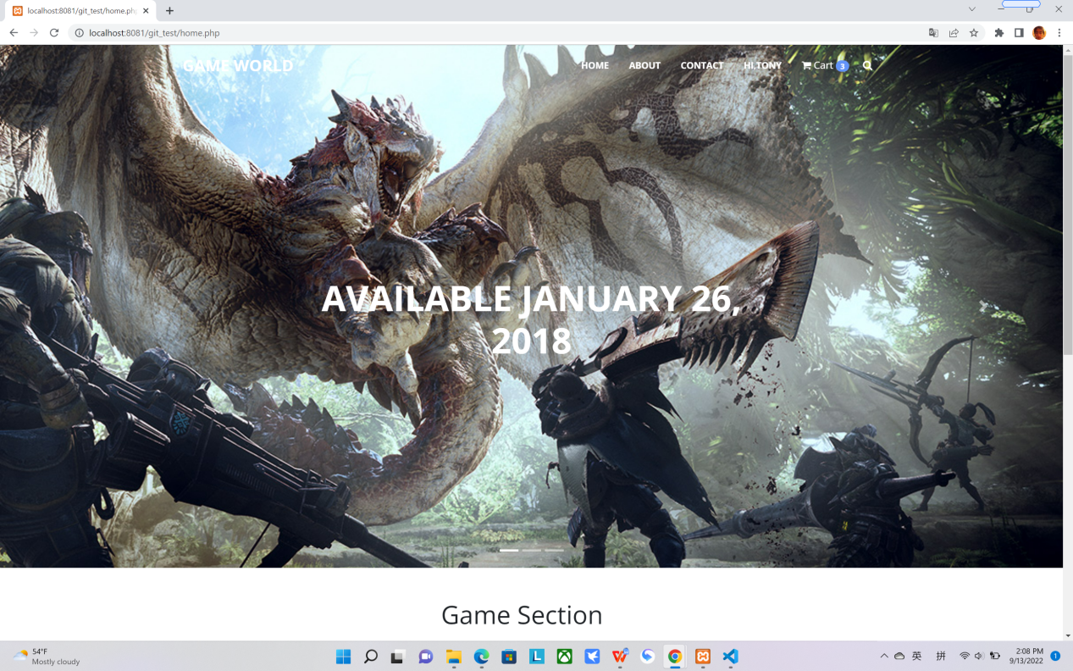

When you hover on the magnifier icon the search bar will show and you could input the keyword you like to search the product.

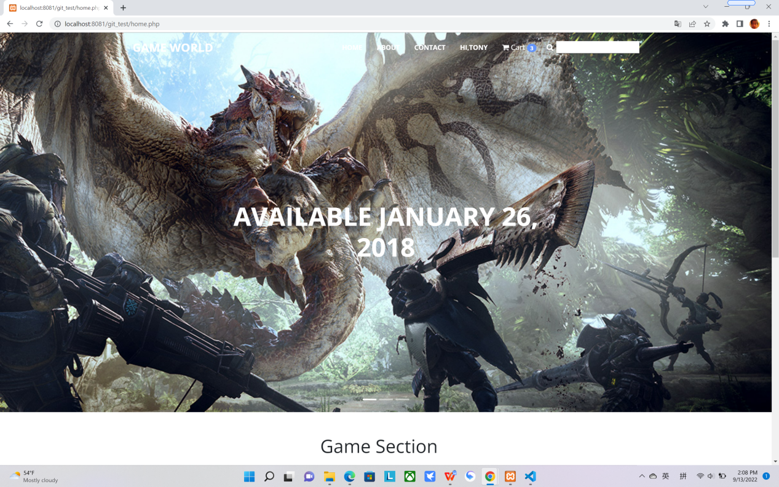

The product info will show up if the keyword can be found it from the database 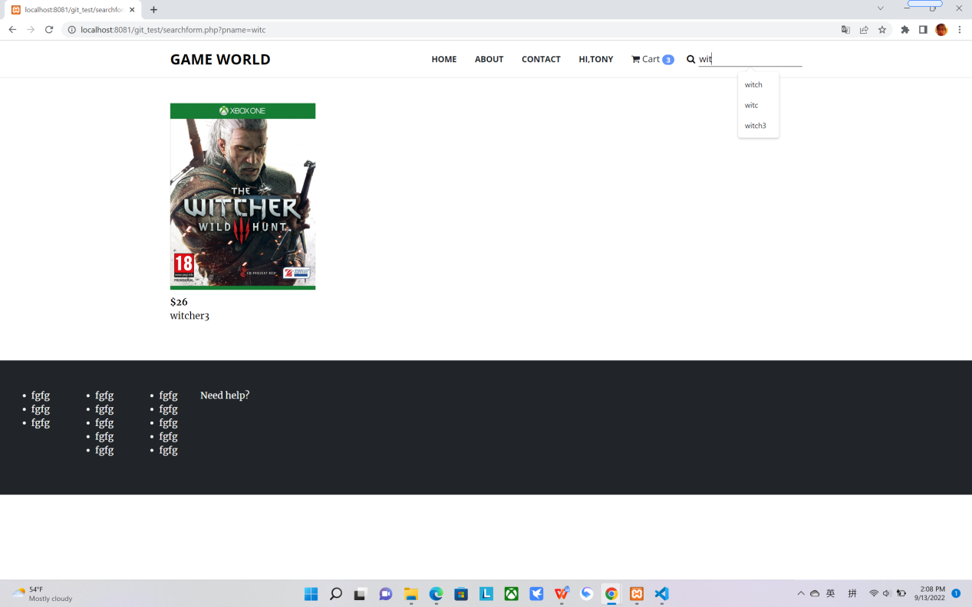

By press your{name} , it will pop up a dialog box to ask for log out, frankly speaking , it is very likely the users click this place by mistake, so I decide ‘close’ button put at left and bigger as people will click more instinctively , ‘yes’ button at right ,so they will only press it if they truly want log out 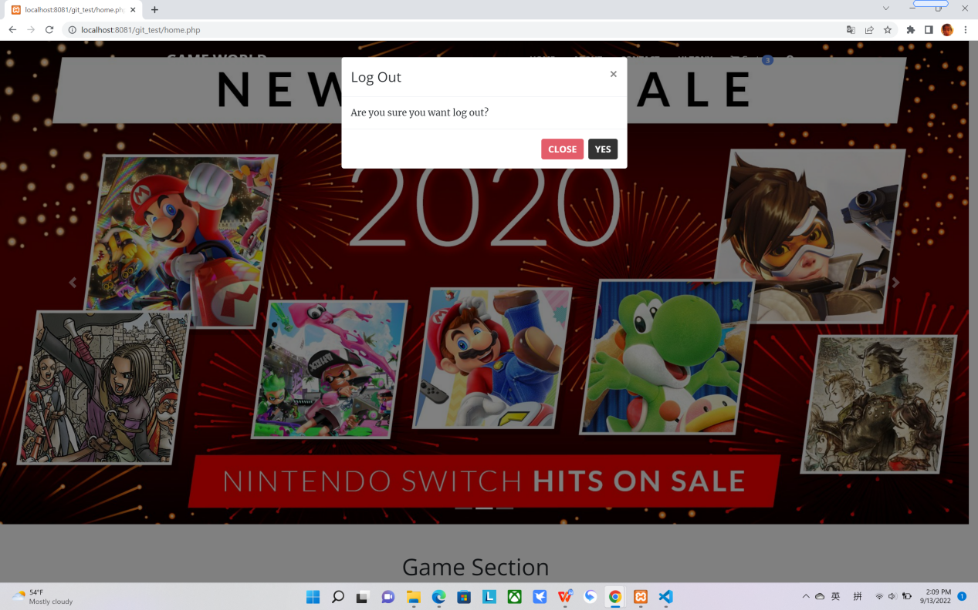

Back to the user selected their product and want to checkout if they already logged in, they will head to the payment page.

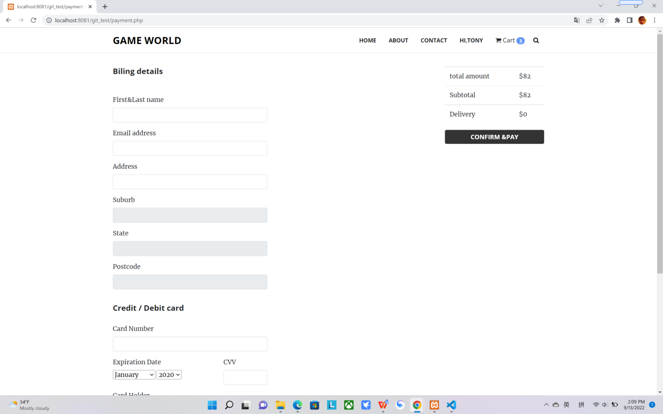

The address will autocratically filled by fill the keywords

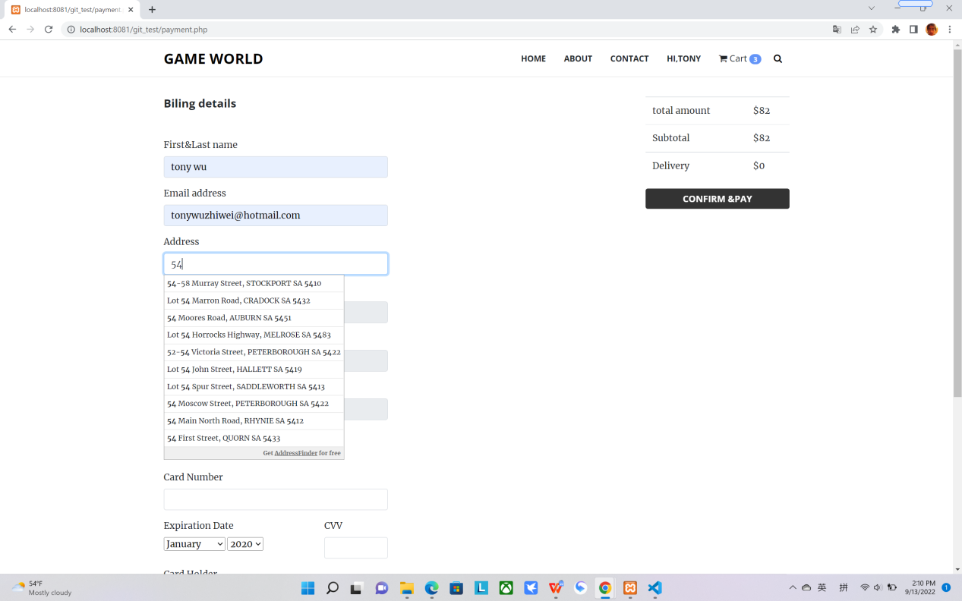

If you don’t input the correct card number it will warning you to input correct one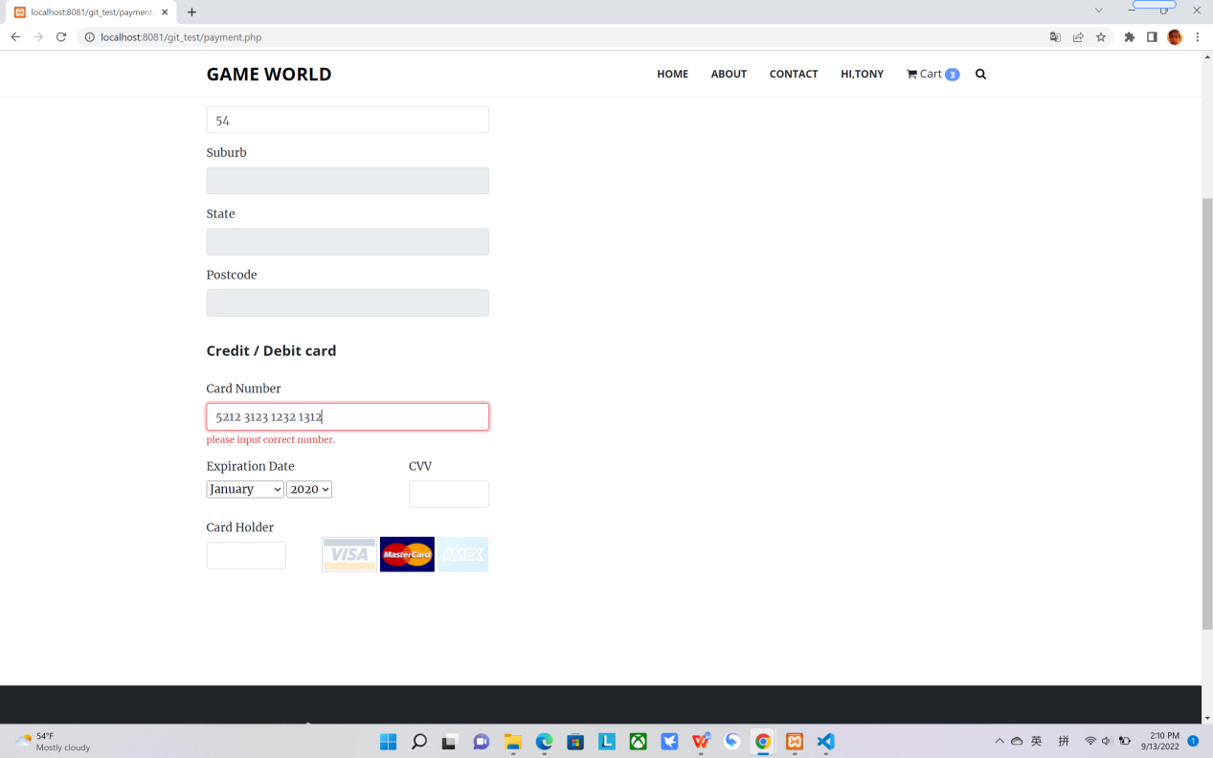

If all the info is filled by correctly, then you will receive the successfully info to tell you the order has been made.

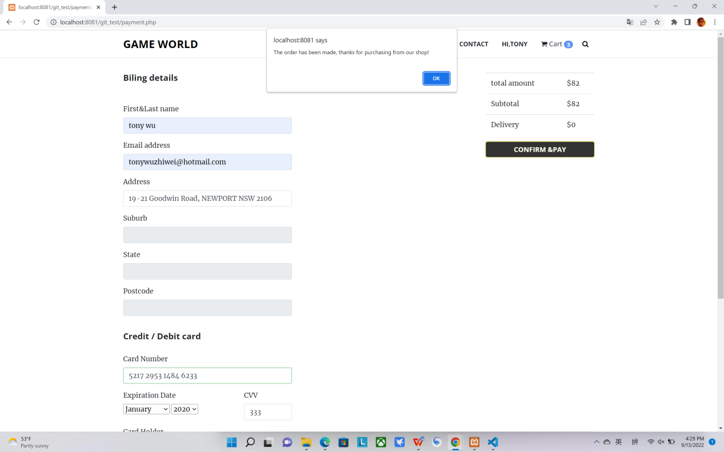

Above are the basic function of this website, I stored user info and product info into the relational database, and rest of are store into the cookie and session. If you have any question please send email to tonywuzhiwei@hotmail.com

Thanks for watching!